LAB Logbook

Lab 1

Lab 2

Test Accuracy: 0.922

Lab 3

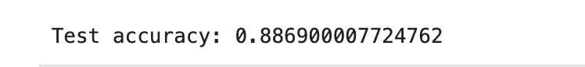

Lab 4

Lab 5

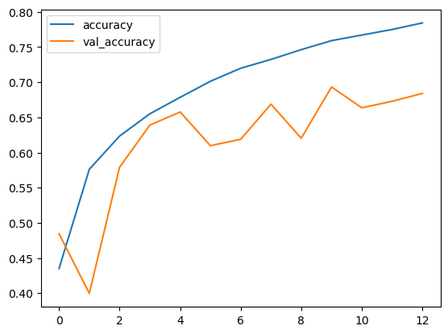

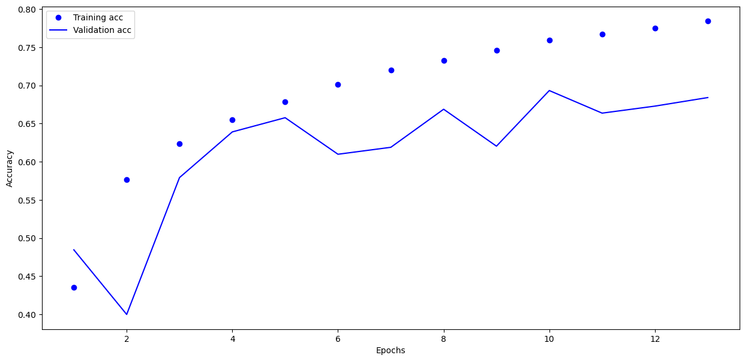

Lab 6

**early-stop code**

early_stop=EarlyStopping(monitor='val_loss',patience=7)

Lab 7

Lab 8

Lab 9

Lab 10

**313/313** ━━━━━━━━━━━━━━━━━━━━ **1s** 2ms/step

Lab 11

Lab 12

